Week 8: Database Relationship Analysis using Joins

Scenario: The e-commerce company stores customer, product, order, and payment information in separate tables. The management team wants to combine these related tables to understand customer purchases, order details, and payment status.

Implement INNER JOIN:
Tasks: 1. Display customer details along with their orders

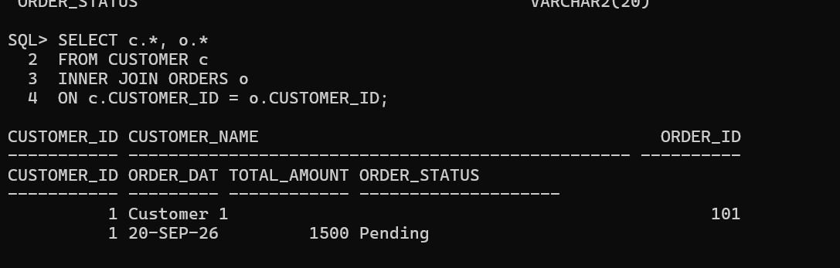
2. Display order details with payment information.
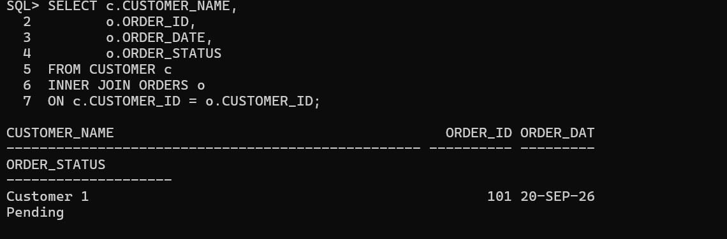

3. Retrieve products purchased by customers.
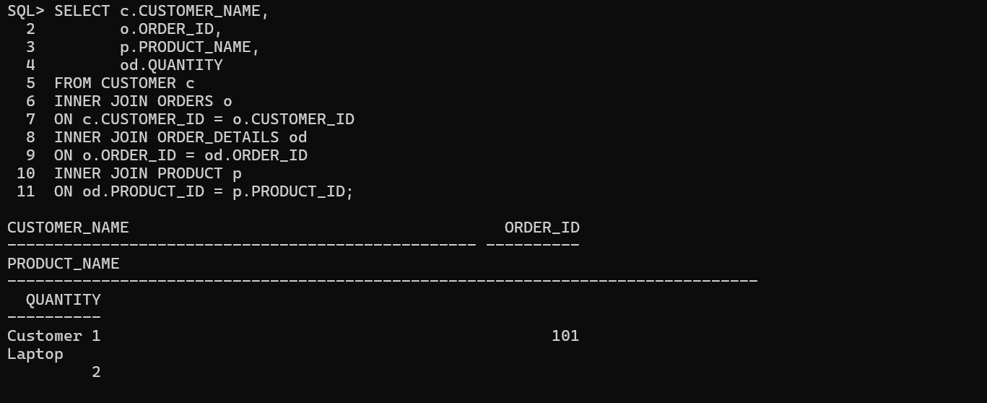
Implement LEFT JOIN
Tasks:
1. Display all customers including customers who have not placed orders.
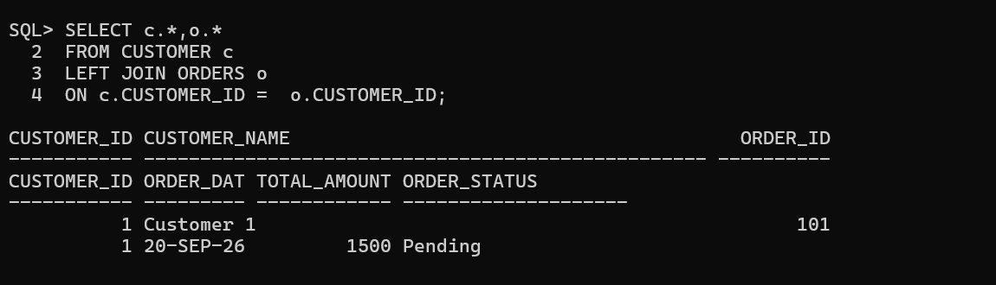

2.Find customers without any purchases.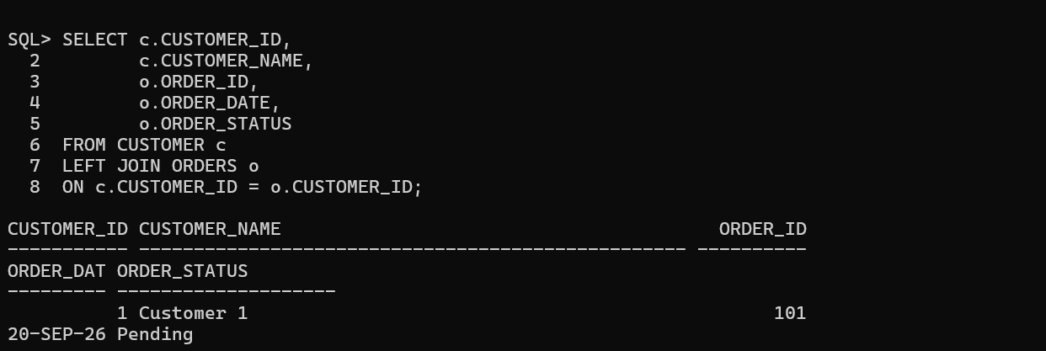

3.Display all products, including products with no sales.

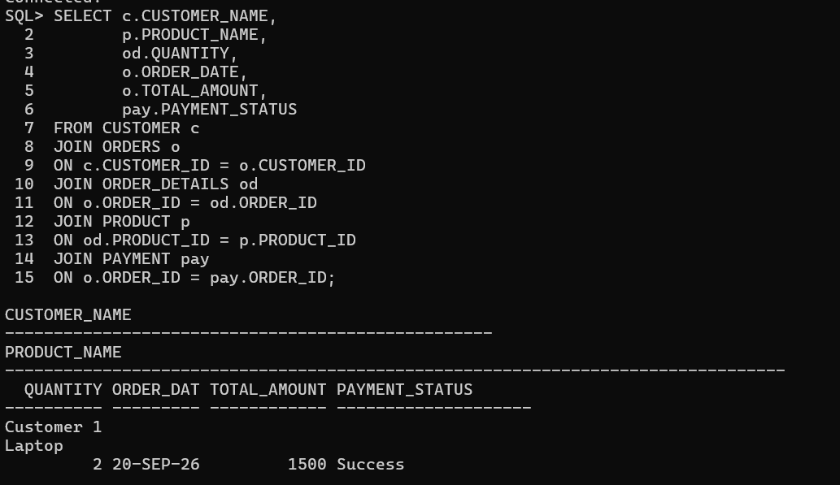

4.Customer Purchase History

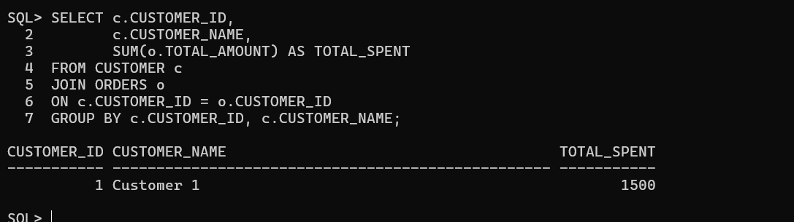

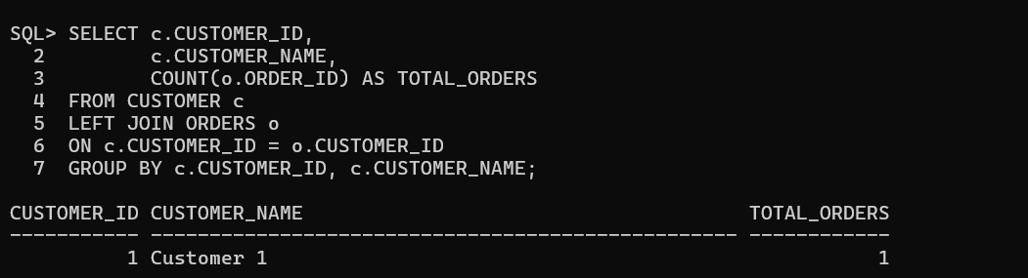

RIGHT JOIN:
1.Display all orders with customer information
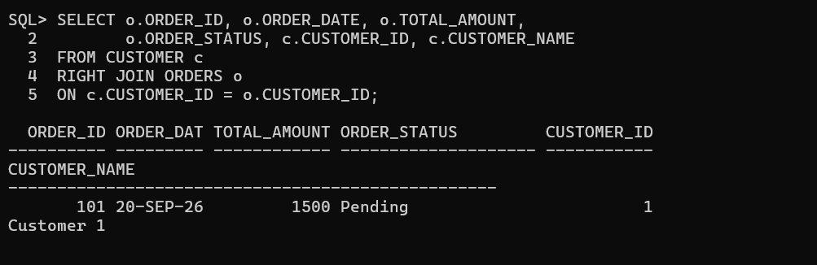
2.Find orders where customer details are missing



3Display all payment records with order details
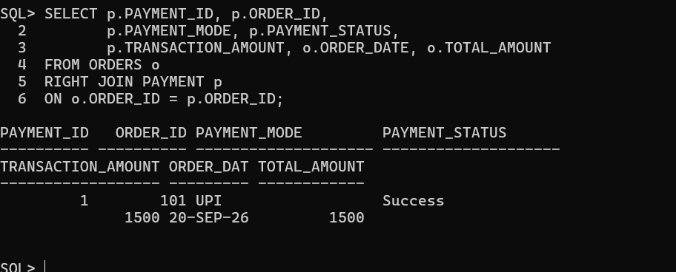

Report 1: Customer Order Report
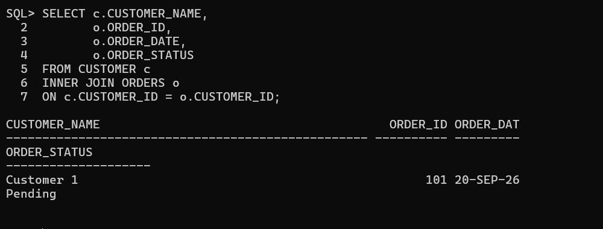
Report 2: Sales Report
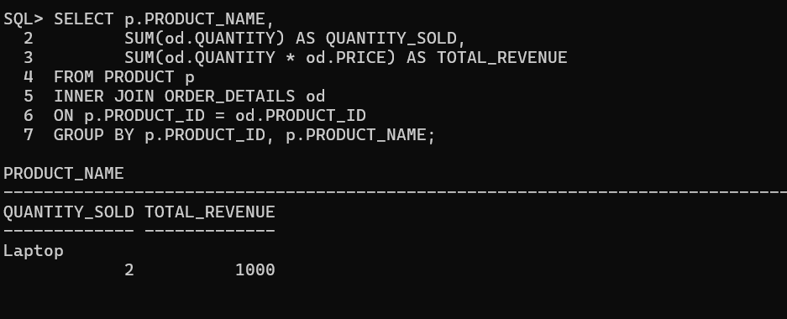
Report 3: Payment Analysis
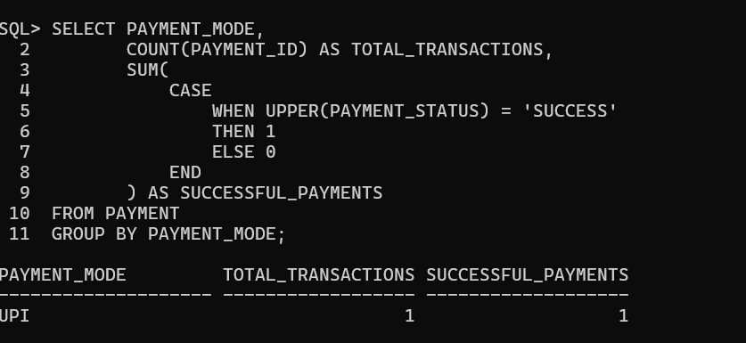

Report 4: Customer Purchase Analysis

